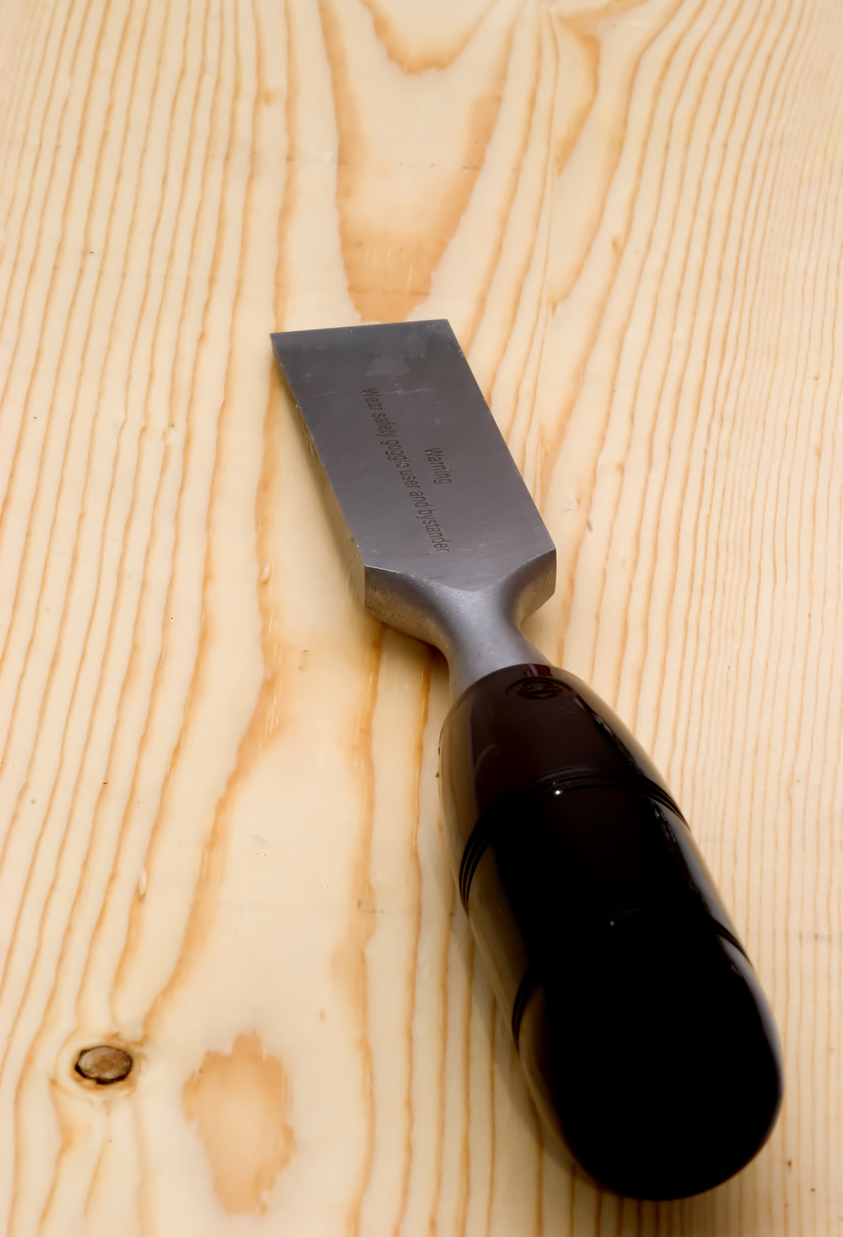

**Tool Safety**

**Hand tools:**

**Do:**

* Use tools only for their intended purpose.
* Keep all tools well-maintained.
* Keep cutting tools sharp.
* Use specially-designed tools when in hazardous environments.
* Store tools in a way that protects their blades and points.
* Use tool-specific personal protective equipment (PPE), such as safety goggles and gloves.
* Keep floor and working area free of debris and spills.

**Do not:**

* Use wrenches with sprung jaws.
* Use impact tools if their heads have mushroomed.
* Use tools with loose or broken handles.
* Use tools with taped handles—the tape could be hiding cracks.