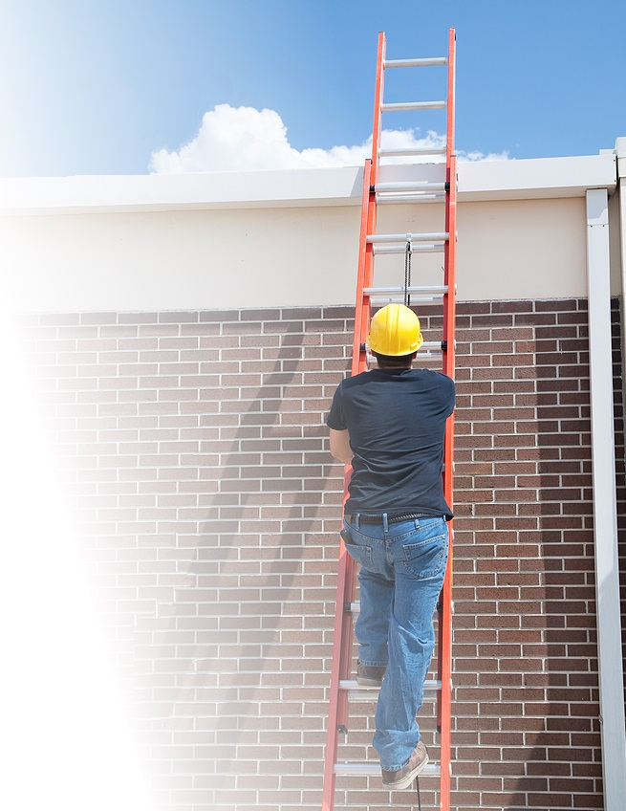

**Ladder Safety**

* Use the appropriate ladder for the job.
* Inspect the ladder for defects before using.
* Check to see if fall protection is needed.
* Place on stable and level ground.
* Assure that load capacity is not exceeded.
* Use three points of contact while on the ladder.
* If a ladder is used to access an upper landing, the side rails must extend three feet beyond the upper landing.
* Place the ladder so that the horizontal distance from the top of the ladder to its base is approximately one-fourth of the working length of the ladder.