Name: Date:
- Match the type of incident to one of its causes.

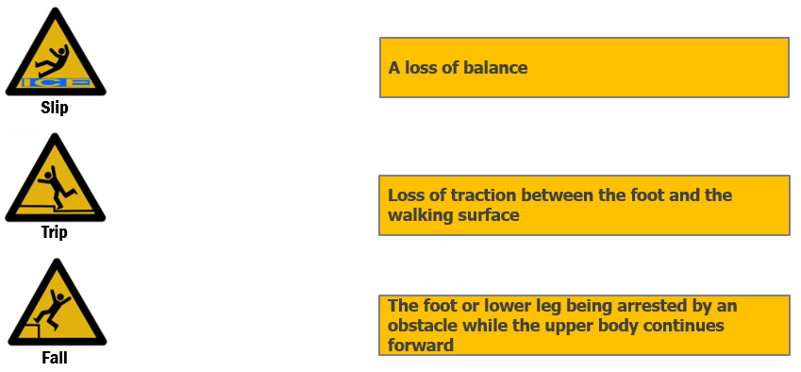

2) Do not run in the workplace.
A. True
B. False

3) Report incidents, but not near misses.
A. True
B. False

4) Choose all that apply. Which hazards should employees fix right away (rather than expecting the employer to fix it)?
A. Spills
B. Poor lighting
C. Unsecure rugs
D. Poor housekeeping
E. Clutter or obstacles
F. Inadequate drainage
G. Uneven walking surfaces

Answer Key
1.
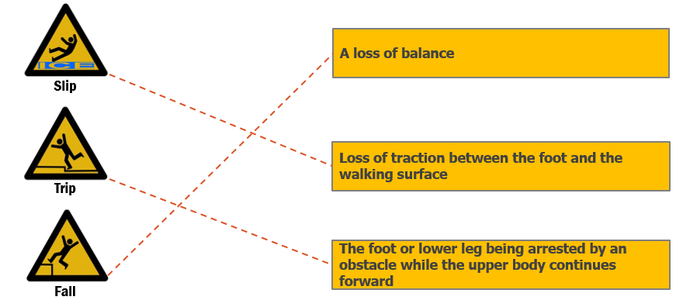
2. A
3. B
4. A, D & E

