WARNING
Arc Flash and Shock Hazard
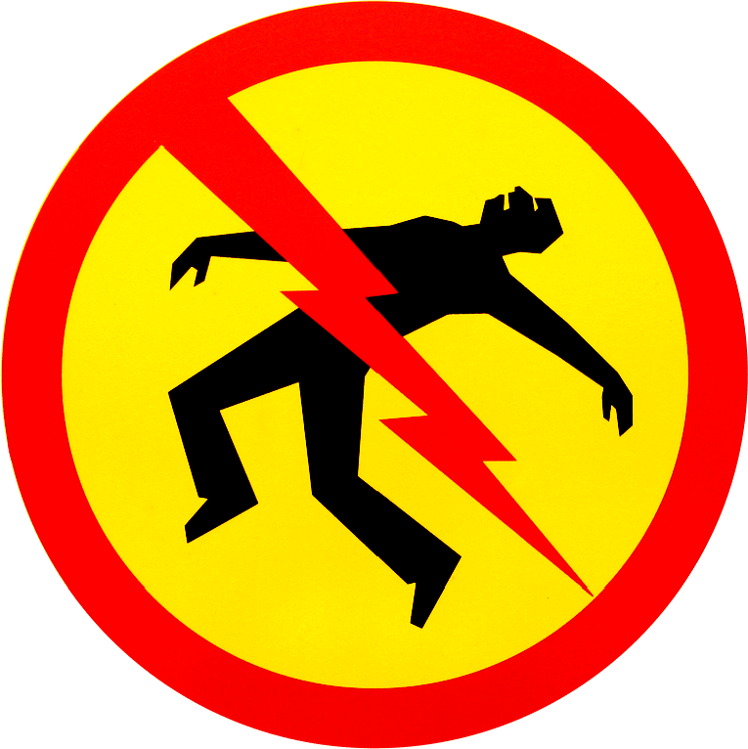

Follow all safety procedures.
Wear proper PPE.
Failure to comply can result in serious injury or death.

