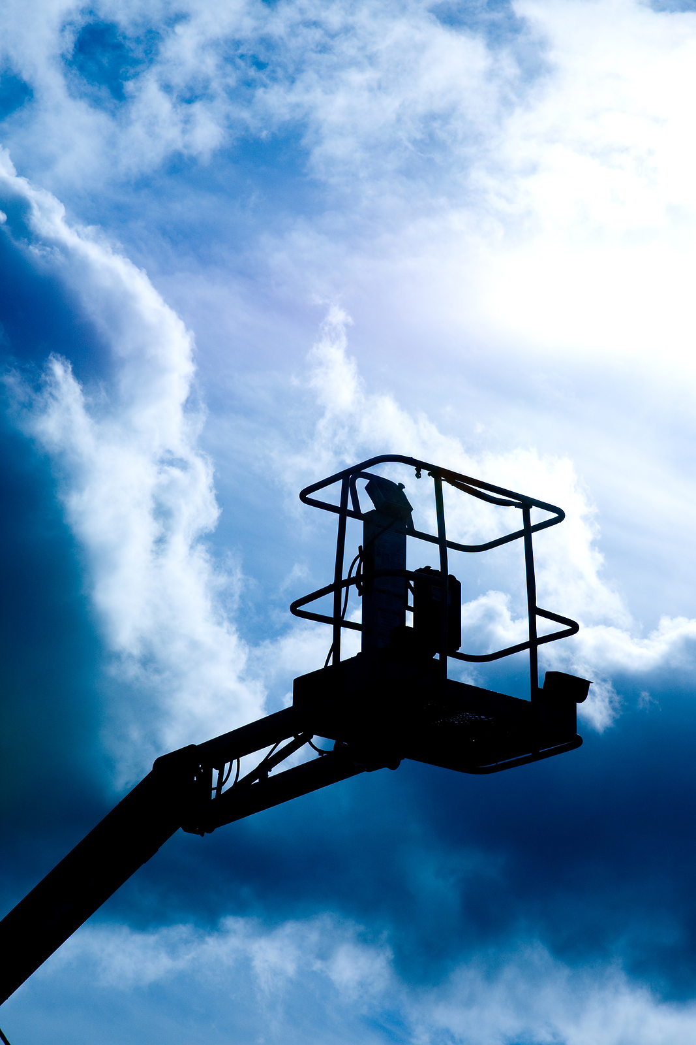

**Aerial Lifts**

**Positioning:**

* Do not drive near drop-offs or holes.
* Do not raise the platform on uneven or soft surfaces.
* Do not drive onto uneven or soft surfaces when elevated.
* Do not raise the platform on slopes or drive onto slopes when elevated.

* Do not raise the platform in windy or gusty weather conditions.