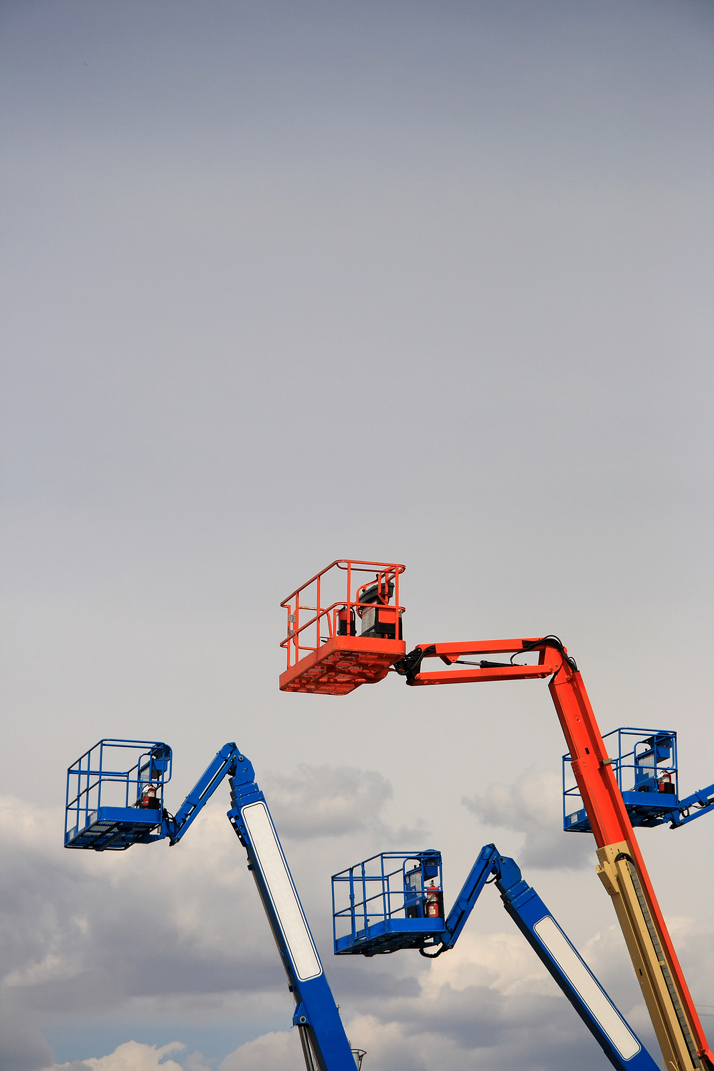

**Aerial Lifts**

**Supervisor duties:**

* Monitor the lift operator’s performance to assure compliance with safety rules.
* Assure that unauthorized persons do not operate lifts.
* Track written pre-start inspections daily.