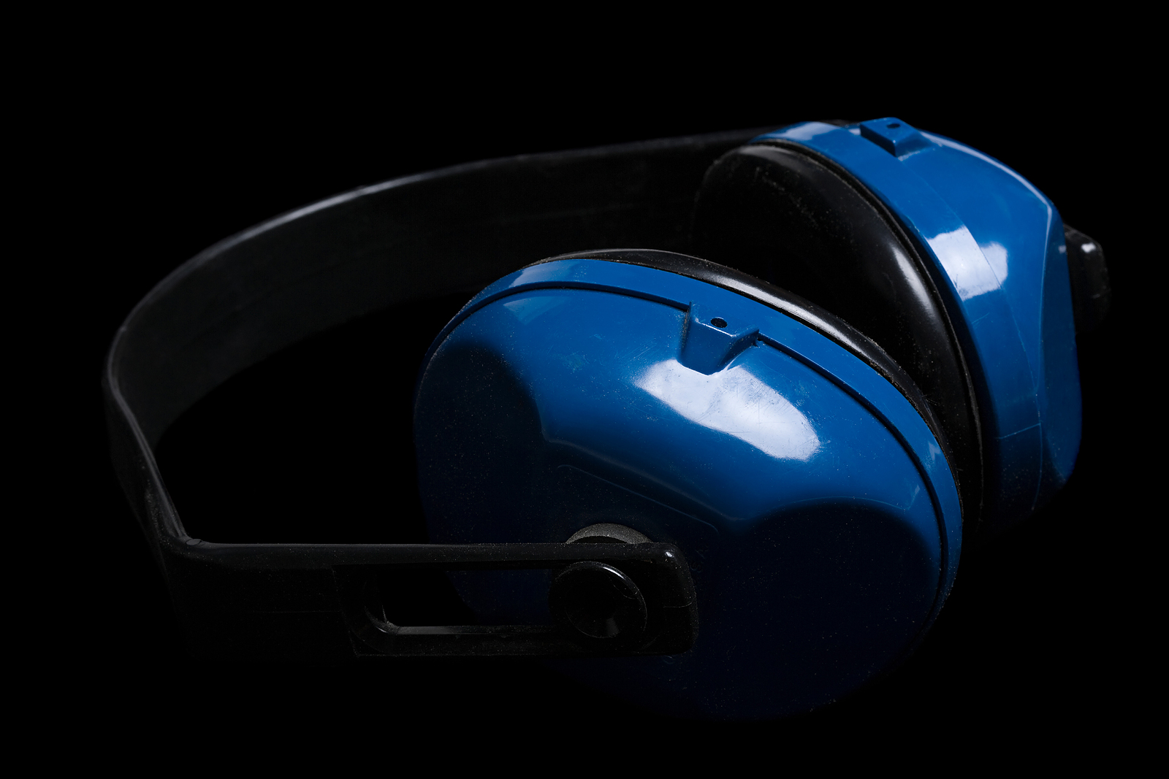

**Noise Overexposure**

**Controls:**

* Engineering
  + Reduce noise at the source
  + Enclose noise at the source
* Administrative
  + Reduce or eliminate employee exposure
* Personal protective equipment (PPE)
* Ear plugs
* Ear muffs