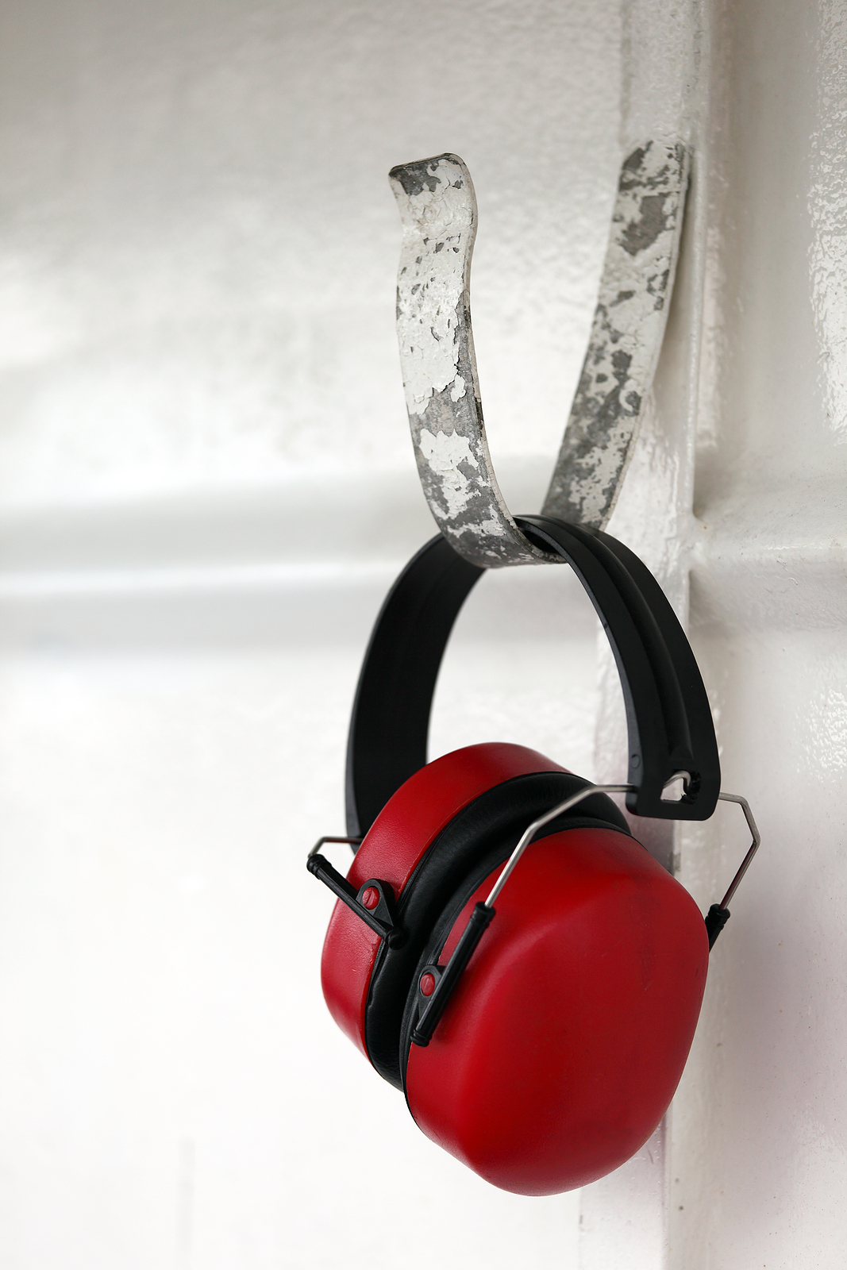

**Noise Overexposure**

**Effects:**

* Interferes with understanding speech and warning signals.
* Interferes with sleep.
* Reduces ability to concentrate.
* Fatigue and stress.
* Reduces efficiency.
* Lowers morale.

*Wear your*

*hearing protection!*