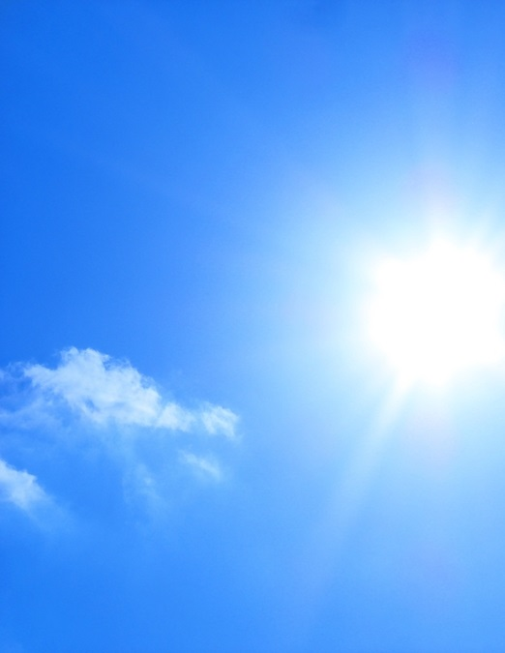

**Heat Stress**

**General symptoms:**

* Fatigue, exhaustion, or weakness
* Cool, clammy, pale skin
* Irritability or confusion
* Dizziness or fainting
* Rapid heart rate
* Heavy sweating
* Muscle cramps
* Slurred speech
* Headache
* Nausea
* Thirst
* Rash