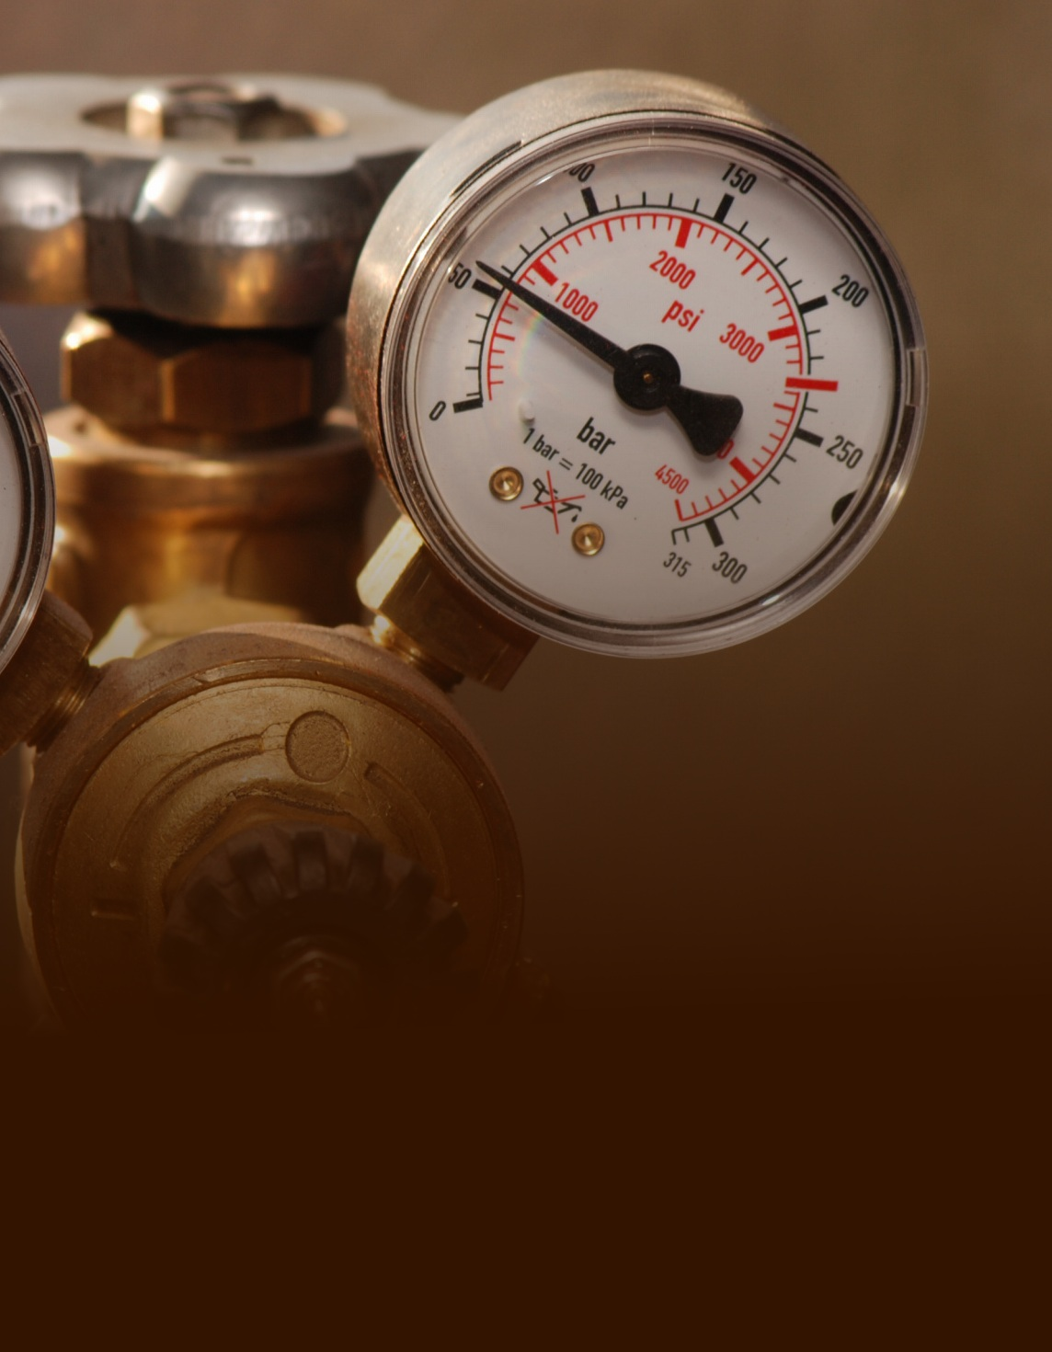

**Tool Safety**

**Pneumatic tools:**

* Keep tools clean, lubricated, and well-maintained.
* Check air hoses frequently for cuts, bulges, and abrasions.
* Assure that the air hose is fastened securely to the tool and held in place with a mechanical device.
* Do not use the hose for carrying, hoisting, or lowering the tool.
* Do not exceed the manufacturer’s safe operating pressure.
* Assure that fastening equipment with an automatic feed is equipped with a safety device to prevent the accidental ejection of fasteners.
* Wear eye, face, and hearing protection, as required.
* Post warning signs, and set up shields to protect others from flying fragments, chips, dust, and noise.